# **Torpor Games Interview Assignment**

The duration of this assignment is **3 days**. You are required to use **Unity 2019.4.5f1**, **C#** as the choice of programming language, **JSON** files as the main data source, **Git** for version control and either **GitHub** or **BitBucket** as the Git platform. Make sure to use Git as if you are working on a real project.

## **Description**

Your task for this assignment is to create various UI elements as per the provided design materials below. The implemented UI needs to be functional, responsive and persistent throughout game sessions.

Once the UI tasks have been completed, you will need to provide a list of test cases that apply to the implementation.

### **Functionality**

Each interactable UI element on the screen (i.e. buttons, scroll bars and text boxes) is expected to be fully functional. In addition, the aim is to have a smooth “feel” to the user experience. The interactions with these elements should not be jarring. Use your own judgement to accomplish these conditions.

### **Responsiveness**

The implementation needs to support 16:9, 4:3 and 21:9 aspect ratios. UI elements should not be cutting off from the screen and they are required to remain functional with aspect ratio changes.

### **Persistence**

You are required to utilize JSON file(s) to save, update and get the data that will be displayed on the screen. Think of these as save game files. We should be able to simply drop them to the location the game is looking at and reproduce the expected results as per the data. Editing the data in the file manually should reflect correctly once the game is restarted.

Determine the data structures used in JSON on a case by case basis and make the right call which fits the situation the most. You will have to use this data to construct some of the lists and containers as seen in the provided design materials below.

You may use placeholders for the content however, make sure they are different from each other for different data entries.

# 

# **Task #1: Codex**

1. Use the provided assets to recreate the layout displayed below.
2. The codex should be the first screen that is displayed once the game is launched.
3. There are 4 main categories in the codex: Characters, Locations, Organisations and History.
4. Each category has one or more unique codex topics. In the example below, they are Cabinet, Family, Party Leaders, etc. You may use placeholder names for codex topics in other categories.
5. Each topic has one or more unique codex entries. In the example below, they are Petr Vectern, Lucian Galade, Lileas Graf, etc. Same as the topics , you may use placeholder names for codex entries.
6. Depending on the clicked UI element, the corresponding topics or entries must be shown.
7. The information in the panel on the right side has to be updated once a codex entry is clicked.
8. Some of the codex entries should have different images and some should have no image based on the data. You may use placeholder images.

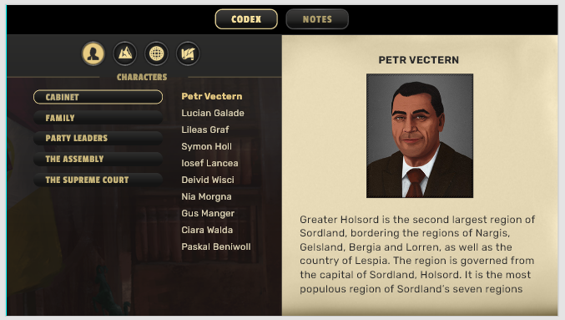

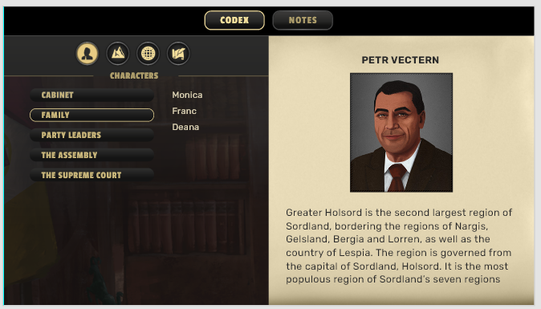

# 

# **Task #2: Notes**

1. Use the provided assets to recreate the layout displayed below.
2. Notes can be accessed from the top menu.
3. There are 4 main categories under the notes: Act I, Act II, Act III, Act IV.
4. Each category shows the notes taken for the selected category.
5. On the left side, the player should be able to enter a note which will appear on the right side.
6. Clicking on a note from the right side will highlight it and a delete icon will appear where deleting a note will remove it from the list.

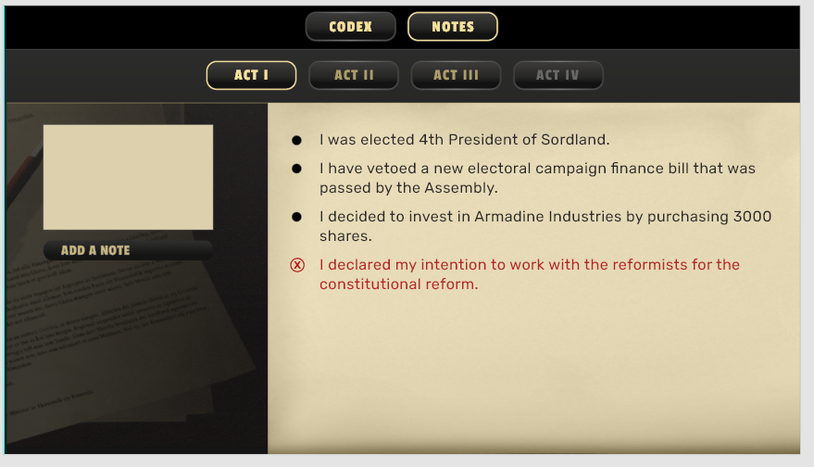

# **Task #3: Test Cases**

For both of the panels implemented for Task #1 and Task #2, write appropriate test cases for various scenarios. These test cases should follow a step by step approach.

Use your own judgement to determine the level of detail required.

**Communication:** Add Kirutosan#8909, Irukesama#5282 and Mr. Nowak#8592 on Discord to communicate instantly. Use [contact@torporgames.com](mailto:contact@torporgames.com) email to reach out for misc comms or other situations as well.